Karthick VM
Batch CIS -1.3
Network Mock Assessment -1

Setup:
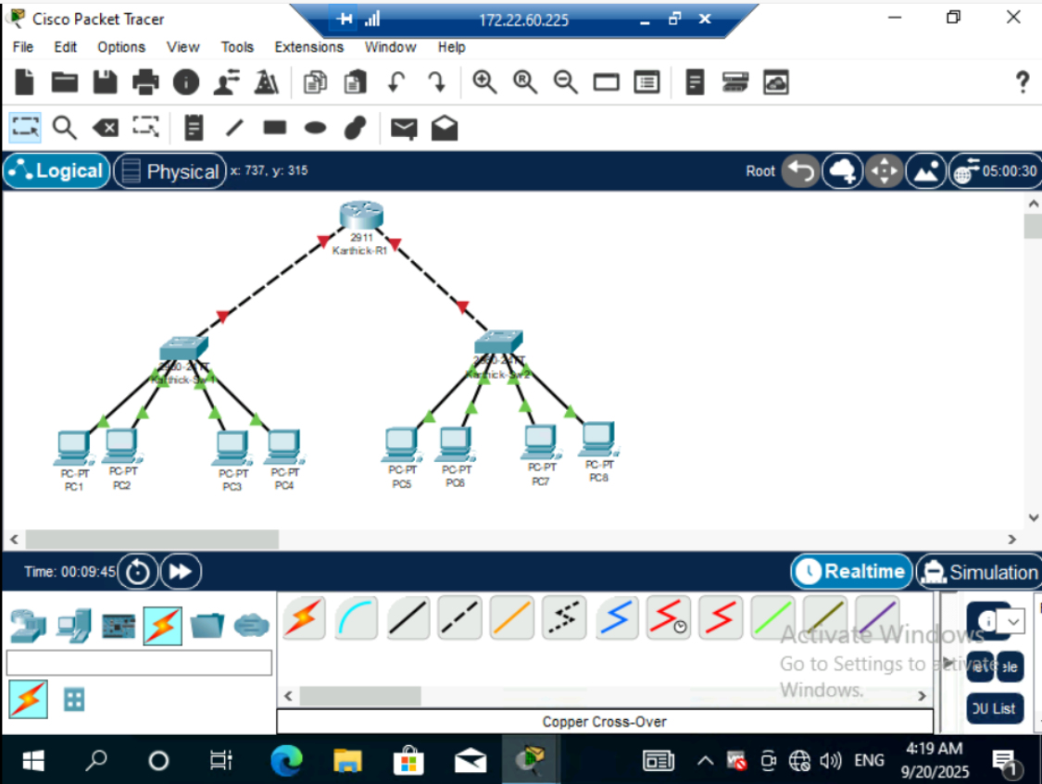

Ip addressing:
- HR

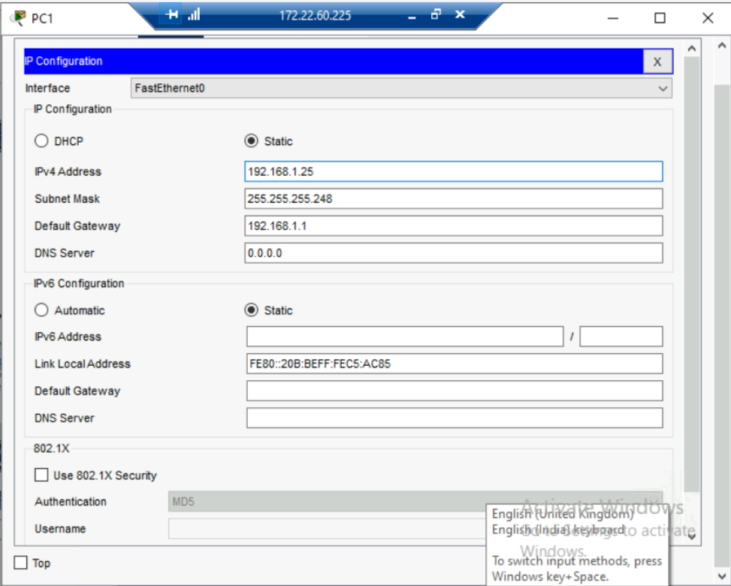
- Finance
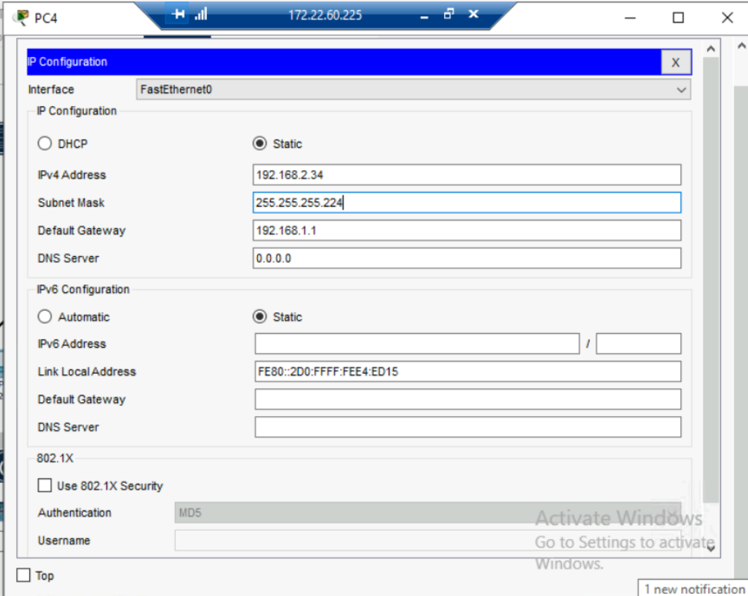

- Admin:
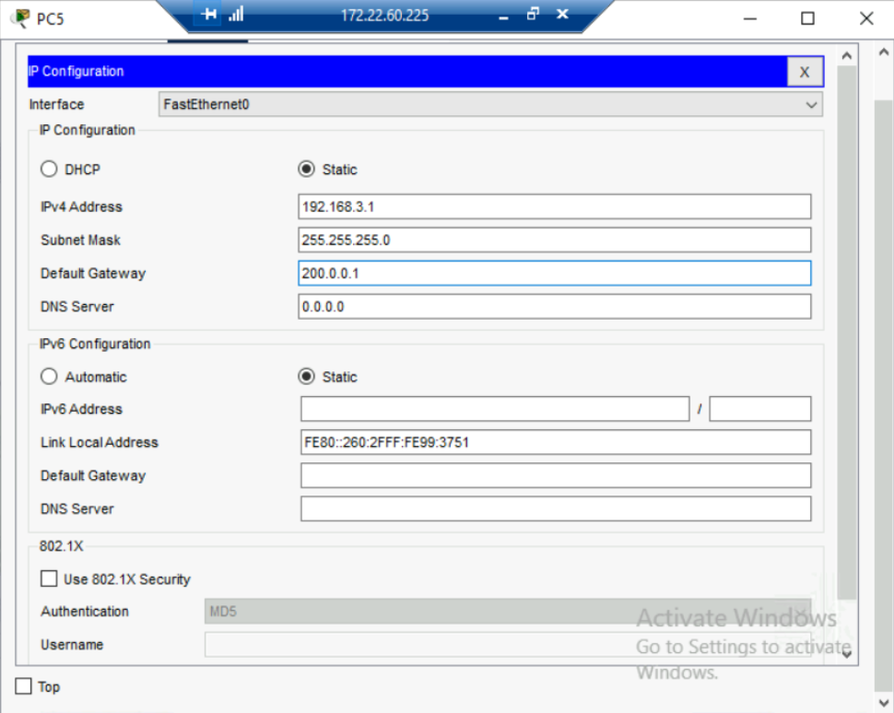
- IT
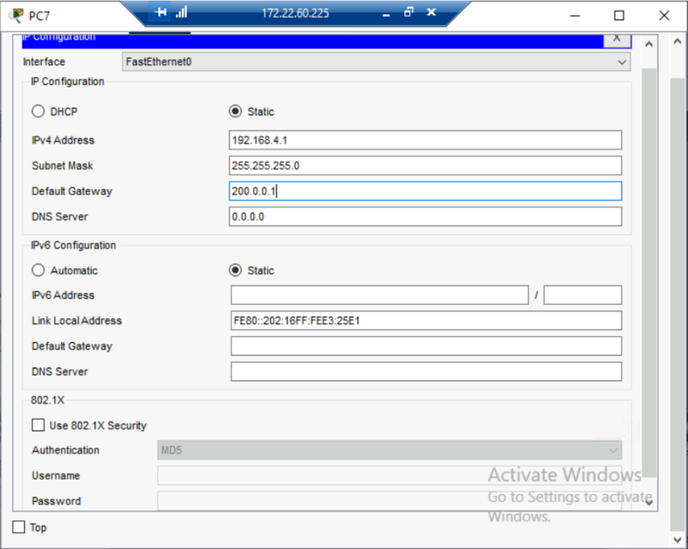

VLAN :
- HR
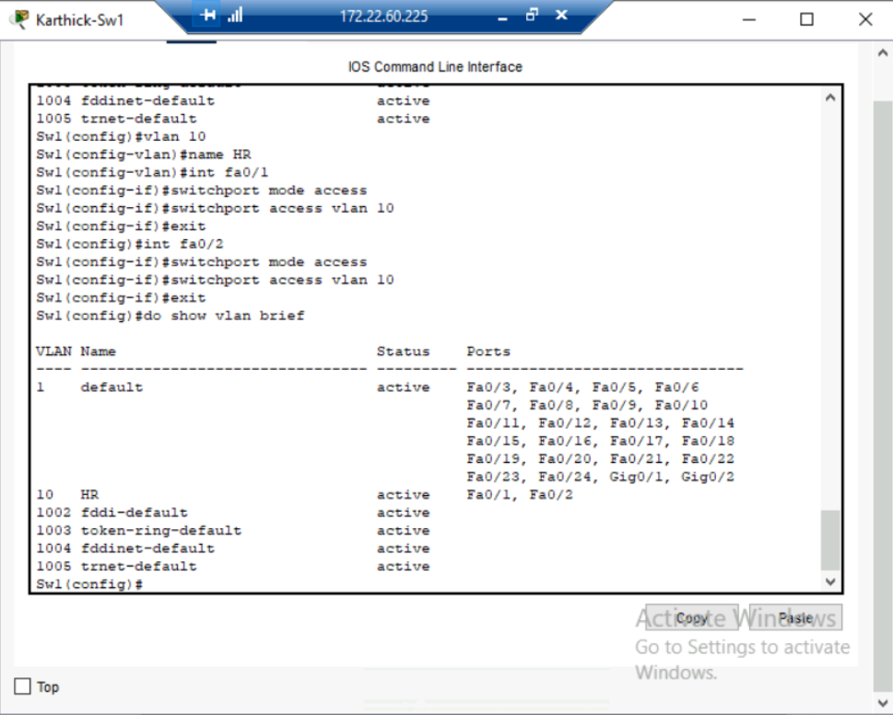
- Finance
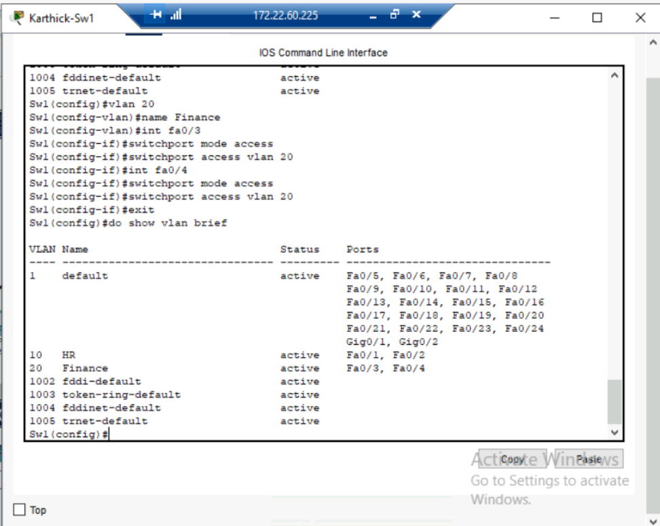
Admin
- 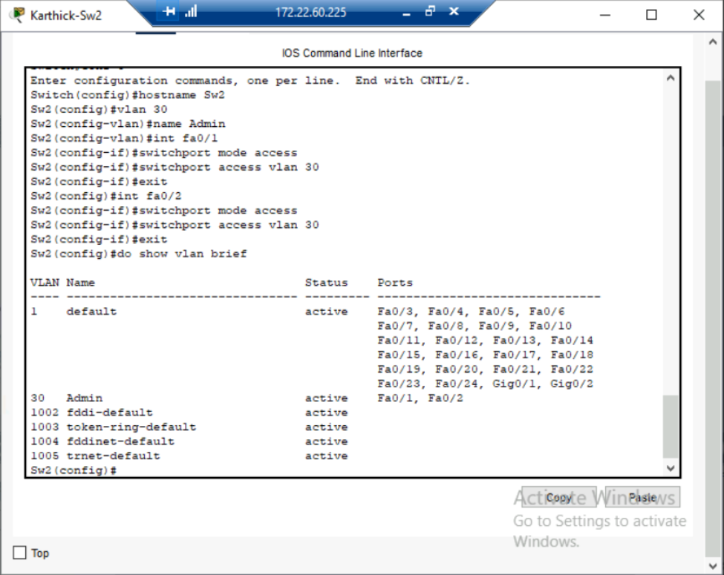
- IT
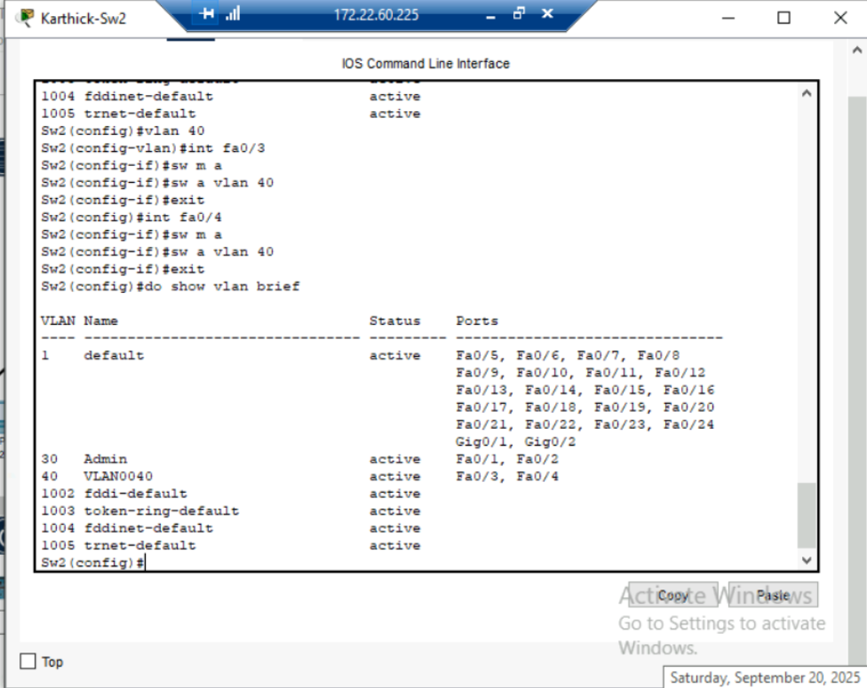
Task 2: Router Configuration • Create sub-interfaces on Router for each VLAN. • Assign appropriate IP addresses to each sub-interface. • Verify connectivity: o Ping from PC1 (HR) to PC6 (IT) must be successful. o Ping from PC3 (Finance) to PC2 (HR) must be successful.
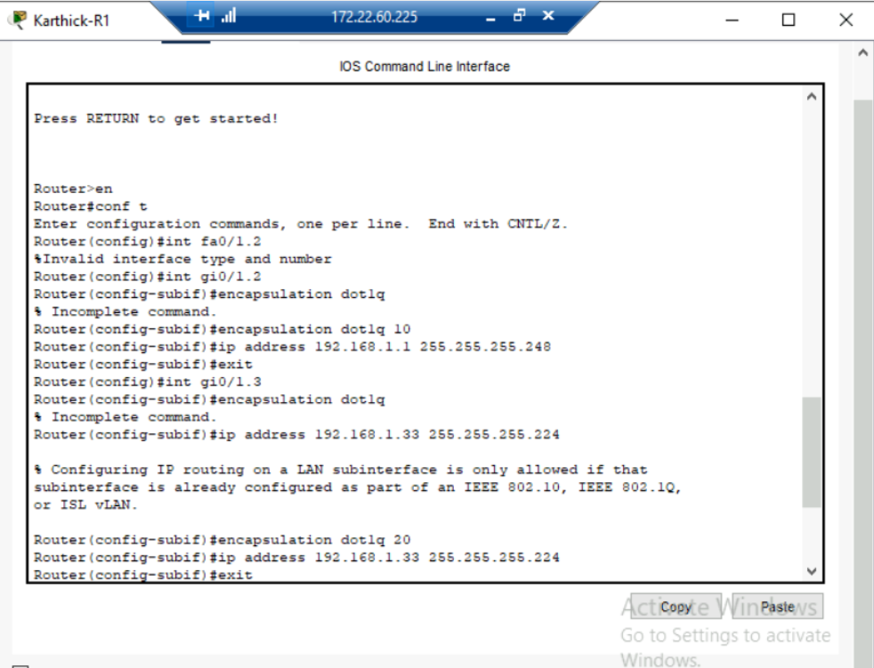
3.Apply Port Security Configure Port Security on Switch1: allow only 2 MAC addresses on port FA0/10 with action shutdown.
